Mediscan: An Multidisease Identification and Prognosis System using AI.

Rohan Kadoo, Mohammad Tahzeeb Khan, Mohammad Hassan Raza, Tanishq Sakhare, Gaurav Dwivedi.

Under-Graduate Student, Under-Graduate Student, Under-Graduate Student, Under-Graduate Student, Under-Graduate Student.

Computer Science & Engineering,

S.B. Jain Institute of Technology Management and Research, Nagpur, India

________________________________________________________________________________________________________

*Abstract:*  The diseases such as heart disease, cancer, diabetes, stroke, and arthritis are the leading causes of disability and death in India and worldwide. Compared to other diseases, these types of diseases are characterized by high mortality. It is therefore necessary to develop a promising solution for chronic diseases. The growth of medical data in healthcare and the accurate analysis of medical data bring benefits for early disease detection, patient care and social services. However, the analysis of patients depends on the correctness of the diagnosis and subsequent treatment. Misdiagnosed patients lead to death from chronic diseases. Due to the high risk of diagnosis, there is therefore a need for accurate diagnostic care for chronic diseases. Therefore, we propose a machine learning-based diagnostic system that offers promising solutions with high accuracy. The proposed system covers the detection of many diseases such as lung cancer, brain tumors and heart diseases, as well as the prediction of developmental stages. The high mortality rate due to chronic diseases such as heart disease, lung cancer and brain tumors requires the development of an appropriate diagnostic system to support doctors. A misdiagnosis of leads to people dying. We therefore need to work on an accurate diagnosis of many diseases. A lot of work has been done on various diseases, but no promising solution for complete and accurate diagnosis has been found. The proposed system covers the detection of many diseases such as lung cancer, brain tumors and heart diseases, as well as the prediction of developmental stages. We are trying to develop a multi-disease detection and disease stage prediction system that enables early diagnosis and saves many lives by reducing mortality from chronic diseases.

*________________________________________________________________________________________________________*

# **Introduction**

In recent years, the integration of artificial intelligence (AI) into various industries has brought transformative advances, and healthcare is no exception. The ability of AI to process complex data, recognize patterns, and make informed decisions has paved the way for more accurate and efficient medical diagnoses and prognoses. This paper introduces "MediScan," a cutting-edge Multi-Disease Identification and Prognosis System that harnesses the capabilities of AI to revolutionize the landscape of medical diagnosis and patient care. The challenge of identifying and prognosticating multiple diseases in a timely and precise manner has long been a central concern in the healthcare industry. Traditional diagnostic approaches often rely on the manual interpretation of medical images, clinical data, and patient history, which can be time-consuming and prone to human error. Moreover, the simultaneous presence of multiple co-existing diseases in a patient further complicates the diagnostic process. MediScan addresses these challenges by leveraging advances in artificial intelligence, particularly in the areas of machine learning, image recognition and natural language processing. system The Study not only aims to identify a broad range of diseases using a variety of diagnostic data, but also provides information about the possible course of these diseases so that healthcare providers can make informed decisions regarding patient care. MediScan is an integrated framework that leverages a diverse dataset encompassing a wide spectrum of medical conditions. Through the amalgamation of machine learning algorithms and deep neural networks, the system demonstrates an exceptional proficiency in concurrently identifying numerous diseases. AI models within the system are trained on extensive datasets to recognize patterns, symptoms, and risk factors associated with multiple diseases simultaneously. This enables rapid and accurate disease identification, even in cases where diseases coexist or present with atypical symptoms. These systems go beyond simple diagnosis by providing healthcare professionals with valuable insights into disease progression and prognosis by analyzing historical patient data, treatment outcomes and the latest medical research, AI algorithms can predict the likely course of the disease. develops and recommends personalized treatment plans.

1. **LITERATURE SURVEY**

Detection of skin diseases using image processing techniques » International Research Journal of Engineering and Technology (IRJET) Volume: 07 Issue: June 6, 2020. Presents an automated method for diagnosing melanoma, practically using a series of thermoscopic images. The resulting topographies are based on a grayscale co-occurrence matrix (GLCM) and the use of a multilayer perceptron classifier (MLP) to classify melanocytic nevi and malignant melanomas. The first approach, “Automatic Iteration Counter,” is faster, but the second, “Standard Iteration Counter,” provides better accuracy, which is 100% for the training set and 92% for the test set. This will be the subject of research will design and study a system that brings together the results of previous images of pigmented skin lesions (PSL), their analysis, relevant observations and hypotheses from medical experts using a prototyping methodology. “Hybrid Deep Learning for Detecting Lung Disease Using Ultrasound” 2021 IJRAR March 2021, Volume 8, Issue 1 This article attempts to explore deep learning techniques for computational analysis of lung ultrasound images, which offer a promising avenue in screening and Diagnosis of lung diseases. . Recent advances in deep learning support the identification and classification of lung diseases in medical images. Detection of skin diseases based on the image Processing Technology » International Research Journal of Engineering and Technology (IRJET) Volume: 07 Issue: The article presents a practical method for the automatic diagnosis of melanoma using a series of thermoscopic images. The extracted topographies are based on a grayscale co-occurrence matrix (GLCM) and use a multi-layer perceptron classifier. June 6, 2020. International Research Journal of Engineering and Technology (IRJET) “A deep learning approach for unprecedented lung disease prediction” This article focuses on the development and implementation of a binary classification model for disease prediction of lung cancer from X-ray images. By harnessing the power of machine learning algorithms, particularly those in the field of computer science known as machine learning, we strive to assign accurate class labels to data in a problem domain. Throughout the project, we use popular Python libraries such as Tensor Flow, Keras and NumPy to increase prediction accuracy. The results of this study provide valuable information for the prediction of lung disease using X-rays and enable potential advances in diagnostic and prognostic methods. Artificial Intelligence Disease Prediction System » International Research Journal of Engineering and Technology (IRJET) Volume: 10 Issue: June 6, 2023 This research paper works with archived medical data expressed as descriptions of possible diseases. Given the breadth of the clinical field, the number of hypotheses contained in the information varies from several to several thousand. Skin Disease Detection Using Machine Learning » 2023 IJCRT Volume 11, Issue 5, May 2023ISSN: 2320-2882 This research paper proposes a system for dissection of skin diseases using color images without requiring the intervention of a doctor. The system consists of two stages: the first is to detect infected skin using color, average clustering and color gradient image processing techniques to identify diseased skin, and the second is to detect the type of disease using artificial neural networks to classify. The system was tested on six types of skin diseases with an average accuracy of 95.99% and the second phase 94.016%. “Deep Learning Based Skin Disease Detection” International Journal of Scientific Research in Science, Engineering and Technology (IJSRSET) In this research paper, we study how these people work based on a network model structure based on Deep Neural Fusion (CNN) developed skin diseases. DenseNet201 and also photos clinical information forms the input for this interbinary classifier, which is used to diagnose local features. Images 2023, 12, 4383 of 19. Only the interim display sample achieved a reliability and sensitivity of 95.1% and 83.5% respectively. Allogenic et al. developed a series of coneural algorithms for the detection of basal cell carcinoma. “Heart Disease Predictive Analytics” 2022 IJCRT Volume 10, Issue 10, October 2022 Several works have been carried out on disease prediction systems using various machine learning algorithms and data mining techniques. KPolaraju et al. proposed the prediction of heart disease using multiple regression model, showing that the MLR model is suitable for predicting heart disease. The work is performed using a training set consisting of multiple instances with specific attributes in question. According to the results obtained, the accuracy of the classification regression algorithm is the best compared to other algorithms. Marjia et al. developed the prediction of heart disease. “Predicting diabetic diseases using machine learning algorithms” 2022IJCRT Volume 10, Number 6, June 2022 ISSN: 2320-2882 Covers diabetic disease prediction using SVM, ANN, decision tree, LR and random forest classifiers. Furthermore, by including all current risk factors in the dataset, we observed stable accuracy after classification and cross-validation. We made it to achieves a stable and maximum accuracy of 90%. The main goal is to find the optimal results in terms of Accuracy and computation time for diabetic disease prediction. " “A Machine Learning Model for Prediction of Diabetes and Hypertension Using Ensemble Learning Approach” Published Paper ID: JETIR 2109310 In this paper they worked on diabetes and hypertension and proposed a disease prediction model to predict and classify the disease based on individual’s risk factor. Various Machine Learning algorithms like Logistic Regression, Support Vector Machine, Naïve Bayes, Multi-Layer Perceptron, knearest neighbours, Decision Tree, AdaBoost, Gradient Boosting, Random Forest are used for prediction of diabetes and hypertension. The results obtained after a comparative study, showed that Logistic Regression obtained high accuracy of 83.16% on diabetes dataset and Decision Tree and Gradient Boosting obtained most effective accuracy of 100% on hypertension dataset. Prediction on Lung Disease Using K means Algorithm” 2014 IJIRT Volume 1 Issue 11 ISSN: 2349-6002. This presents prediction on lung disease using K means algorithm. This project comprises of three modules. First, admin module which is administrator’s login there the details of the patient will be generated. Now the user will authenticate based on their credentials. The Second module is User module there the patient enters his username and password to predict cancer. Third module is Cancer prediction module in which the result will be predicted at the last stage with the help of K means algorithm. The K means will classify the input features into two classes of cancer type (benign and malignant). A various Study of MRI brain Image based on Segmentation” 2019 IJRAR June 2019, Volume 6, Issue 2. This paper seeks to explain BT, its forms and various methods of brain tumor identification and segmentation. The aim of survey paper is to present different automated brain MRI BTS methods. The current brain tumor detection (BTD) and brain MRI segmentation techniques are explored.

1. **RESEARCH METHODOLOGY**

The field of healthcare is characterized by the complexity and diversity of diseases, often requiring accurate and timely diagnosis for effective treatment. However, the traditional diagnostic approaches are limited by their reliance on manual analysis and expertise, leading to potential errors, delays, and missed opportunities for early intervention. Moreover, the increasing volume of medical data, including images, patient records, and clinical notes, poses a significant challenge for healthcare practitioners to efficiently and comprehensively identify and prognose multiple diseases simultaneously. In light of these challenges, the development of an advanced Multi-Disease Identification and Prognosis System using AI, referred to as "MediScan," aims to revolutionize disease diagnosis and patient care. This system seeks to leverage the power of artificial intelligence to accurately and efficiently identify a wide range of diseases from various diagnostic inputs while also providing prognostic insights for personalized treatment planning. These systems go beyond simple diagnosis by providing healthcare professionals with valuable insights into disease progression and prognosis. By analyzing historical patient data, treatment outcomes, and the latest medical research, AI algorithms can predict how a disease is likely to develop and recommend personalized treatment plans. In contemporary healthcare, the accurate and timely identification of multiple diseases in patients is a complex and resource-intensive challenge. Traditional diagnostic methods often rely on individual expertise and subjective interpretation, which can lead to delayed diagnoses and suboptimal treatment outcomes. To address these issues, there is an imperative need to develop a Multi-Disease Identification and Prognosis System leveraging Machine Learning (ML) and Deep Learning (DL) techniques.

1. **PROPOSED SYSTEM**

* To identify multiple diseases.
* Advancement of Machine Learning Technique.
* To Enhance Patient Care.
* Support for Healthcare Decision making.
* Real-Time Analysis.
* Accuracy Enhancement.
* Prognosis Capability.
* Transfer Learning.
* Multi-Model Integration.
* Data Quality and Preprocessing.

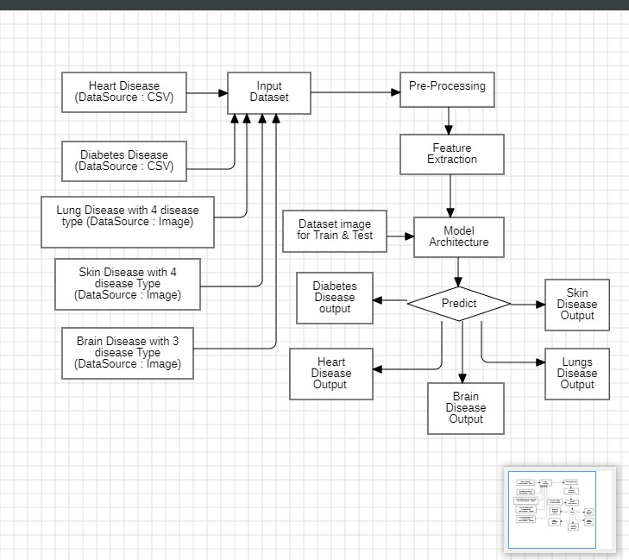

System Architecture

**Proposed Modules/Steps:**

* Download the Datasets and Extract them.
* Defining the Directories in Dataset.
* Define the Model.
* Data Pre-processing.
* Training the Model.
* Running the Model.
* Creating a Web Application.
* Deployment.

**Proposed Algorithm**

* We use CNN architecture to train to find out different types of disease with the help of image datasets.
* We will create a architecture layer over a CNN with the help of Resent, VGG16 Models.
* We also find out diseases with help of Machine learning Approach.
* We create User Friendly Interface to upload images data and prediction of expected output.

1. **CONCLUSION**

This System can contribute to educating healthcare professionals, patients, and the general public about the importance of early disease detection, prevention, and management. Overall, the expected outcomes of a multi-disease identification system is to enhance our ability to detect and manage diseases more effectively, ultimately improving healthcare outcomes and public health. Multidisease identification system can advance scientific research by providing a better understanding of disease mechanisms, genetics, and epidemiology. This knowledge can lead to further research opportunities and discoveries.

# **References**

[1] “Skin Disease Detection using Image Processing Technique” International Research Journal of Engineering and Technology (IRJET) Volume:07 Issue: 06 June 2020.

[2] S. Manogaran, and D. Lopez. Authors: S. Manogaran, and D. Lopez. Published in Journal of King Saud niversity - Computer and Information Sciences, 2018 “Prediction of Hurt Disease using deep Learning Techniques”

[3] S. B. Kang, Y. K. Cho, and D. R. Lee. “Deep Learning for Brain Tumor Classification” Computational Intelligence and Neuroscience, 2019.

[4] Ishaq Azhar Mohammed. (2019). A SYSTEMATIC LITERATURE MAPPING ON SECURE IDENTITY MANAGEMENT USING BLOCKCHAIN TECHNOLOGY. International Journal of Innovations in Engineering Research and Technology, 6(5), 86–91.

[5] Abbas Khosravi ,Syed Moshfeq Salaken, , Amin Khatami, Saeid Nahavandi, Mohammad Anwar Hose “Lung Cancer Classification Using Deep Learned Features on Low Population Dataset” IEEE 30th Canadian Conference on Electrical and Computer Engineering (CCECE) 2017.

[6] Hasan, A., Meziane, F., Aspin, R., & Jalab, H. (2016). “Segmentation of Brain Tumors in MRI Images Using Three-Dimensional Active Contour without Edge. Symmetry,” 8(11), 132. doi:10.3390/sym8110132.

[7] Shadab Adam Pattekari and Asma Parveen “PREDICTION SYSTEM FOR HEART DISEASE USING NAIVE BAYES.” International Journal of Advanced Computer and Mathematical Sciences 2015.

[8] S.Florence, N.G.Bhuvaneswari Amma , G.Annapoorani , K.Malathi (2015). “Predicting the Risk of Heart Attacks using Neural Network and Decision Tree.” International Journal of Innovative Research in Computer and Communication Engineering 2014 .